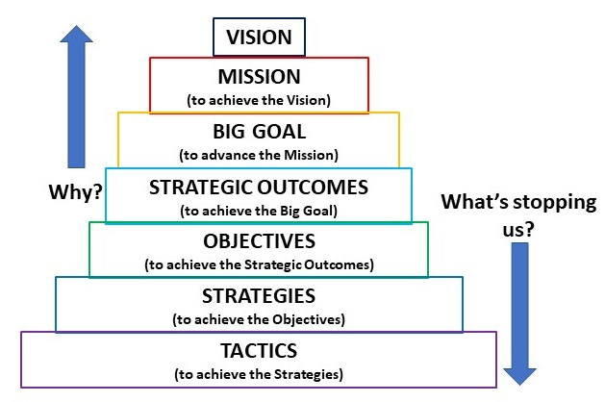

VISION: women and girls have the resources and opportunities to reach their full potential and live their dreams
MISSION: Soroptimist improves the lives of women and girls through programs leading to social and economic empowerment
BIG GOAL: to increase our collective impact by Investing in the Dreams of one million women and girls through access to education

Strategic Outcome: IMPACT (PROGRAM PILLAR)
Together, we will provide a sustainable impact on the lives of women & girls who face obstacles such as poverty, violence and teen pregnancy
Objectives | Strategies | Tactics
- GWR will increase the impact of the Live Your Dream Award | - Give more awards to women through LYDA  - Support the focus on our target population  - Include online applications in club judging  - Provide additional resources to the LYDA winners
- Increase the impact of Dream it, Be it | - Empower girls through DIBI  - Support the focus on our target population  - Comply with SIA’s procedure for working with youth  - Report impact of club projects through online database
- Increase engagement in our LYDA | a. Participate in the LYDA  b. Cultivate partnerships locally to deliver the LYDA
- Increase engagement in DIBI | a. Participate in the DIBI  b. Cultivate partnerships locally to deliver the DIBI
Strategic Outcome: ENGAGEMENT (MEMBERSHIP PILLAR)
Members will find value through engagement with our mission
Objectives | Strategies |  | Tactics
- Increase new clubs | - Charter new clubs  - Mentor/Develop new clubs
- Increase members in clubs | - Recruit new members  - Retain Existing members
- Increase the quality of engagement within our organization | - Create enjoyable and civil member experience  - Communicate value to members  - Onboard new members  - Leverage LiveYourDream.org as an engagement strategy
- Enhance our effectiveness for collective, sustainable impact | - Advocate for SIA’s strategic priorities  - Support and encourage clubs to align the member experience with SIA’s brand promise  - Celebrate club, region and organizational success and progress
- Increase the capacity of members to be effective leaders within our organization | - Identify future leaders  - Develop future leaders

Strategic Outcome: RECOGNITION (PUBLIC AWARENESS PILLAR)
We are recognized for our efforts to improve the lives of women & girls who face obstacles such as poverty, violence and teen pregnancy through our Dream Programs
Objectives | Strategies | Tactics
- Increase awareness of our Soroptimist brand | - Promote region LYDA recipients  - Develop a web/social media strategy
- Enhance the clubs’ ability to raise awareness of Soroptimist in local communities | - Embrace SIA’s branding and recognition strategies  - Implement SIA’s branding and recognition strategies  - Promote the impact of their local Dream programs
Strategic Outcome: PHILANTHROPY (FUND DEVELOPMENT PILLAR)
Donors will fully fund our Dream Programs
Objectives | Strategies | Tactics
- Increase financial support of Soroptimist brand-unifying Dream Programs | - Encourage clubs to contribute at least 10% of locally raised funds to Club Giving  - Make SIA a recipient of their philanthropic intent  - Contribute to Founder’s pennies | - Increase the annual fund donations  - Increase donations through major gifts  - Increase donations from external sources

NOTES:

